**Simulation**

First Attempt = 8->0->6->2->A->1->A->A

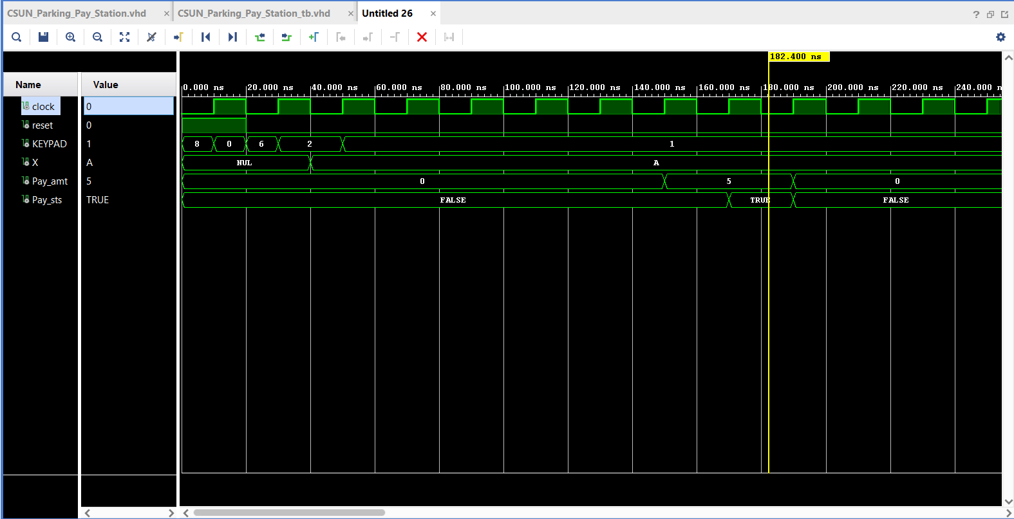

Second Attempt = 4->2->4->D->7->6->A->2->A->A

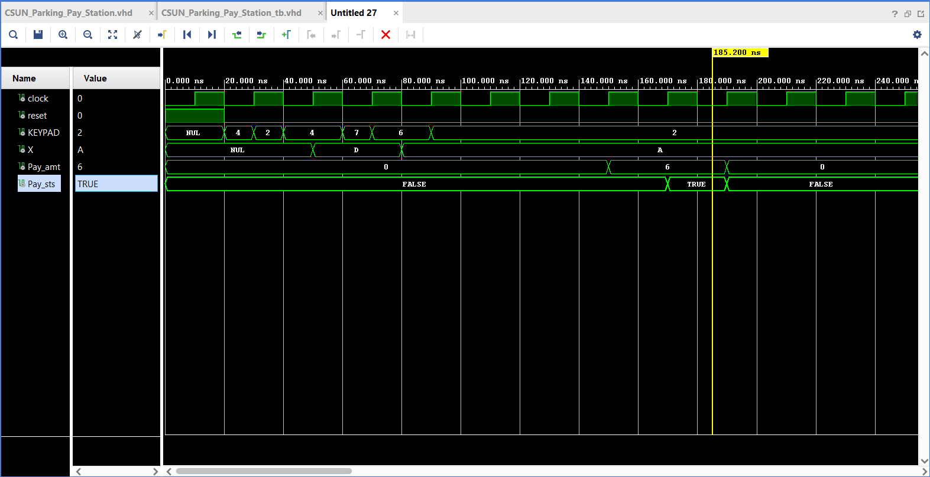

Third Attempt = 4->2->4->D->7->6->A->2->A->C

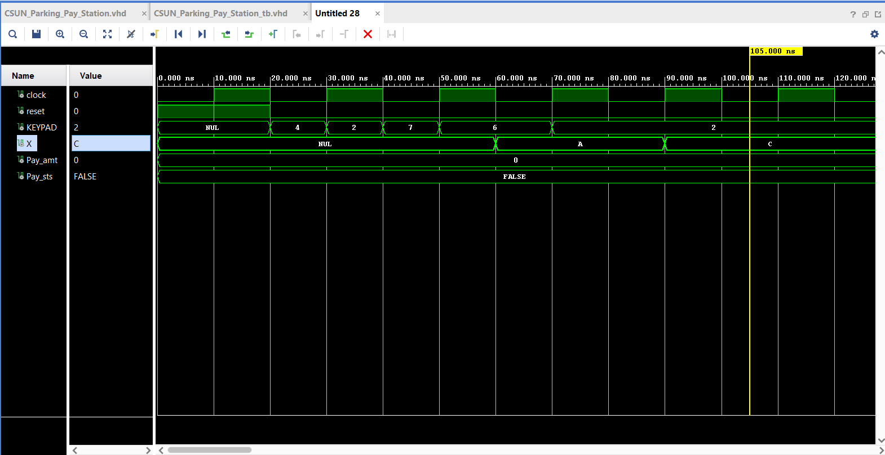

Fourth Attempt = 5->6->3->7->A->3->A->A

